April 29th, 2012
Hi
Well, today is the last full day in the hotel suite. Checkout is at or before 3 pm tomorrow. So the last sleep in the hotel tonight, first in the flat tomorrow. The flat is essentially complete now; just a few things for lunch today and breakfast tomorrow left in the hotel. I brought over the last trolley load of stuff this morning. The telephone company came on Friday to connect the line. I still have to get a TV (I could live without it but will probably get a set). The only issue remaining concerns the bedroom curtains - they are about 5 cm too short! Either the guy measured the height incorrectly or the people making them made a mistake. I have to wait a week for the new curtains. But the guy let me use the present curtains for the week.
Here is the address - update your records:
Flat G, 16/F, Tower 9
Central Park Towers II
2 Tin Yan Road
Tin Shui Wai
Hong Kong
Telephone: (852) 3916 5751
We have been having a lot of thunderstorms and heavy rain in the past two weeks. Still, I managed to get in four swims this past week. Tomorrow morning, I will try to get in another swim, probably the last at the hotel. I have not decided whether to use the facilities here or at the hotel. Here is much cheaper, the pool is nice (and shaded more form the sun, at least later in the afternoon, which is good for me) but the gym is not very good. Also, they are not able to give a date for the opening of the pool here! Still, I will have a few days off exercise then decide.
Last Wednesday, April 25th, was ANZAC day. I watched the ANZAC dawn services from Gallipoli and then from NW France (near Amiens). I have watched the Gallipoli in previous years but no others. The format is similar. This year they had the Australian corporal who won the VC in Afghanistan read that famous verse “They shall nor grow old.......”; a good choice of reader. The Australian PM also attended the Gallipoli service. I picked up from the commentary a few interesting titbits. For example, the NZ contingent was about 9000 strong and of those, about 40% were killed. That 9000 represented about 1% of NZ's then population, a whopping percentage and just for a single battle! (To put that into your context, imagine 1% of the US population, about 3.5 million being thrown into just one battle!) At the ceremony in France, there was a school choir and band-orchestra. These, together with political and military dignitaries at both services, must have cost the Australian a packet! I do not know if Nana's uncle went to Gallipoli first then to the Western Front (many did) or went straight to Europe.
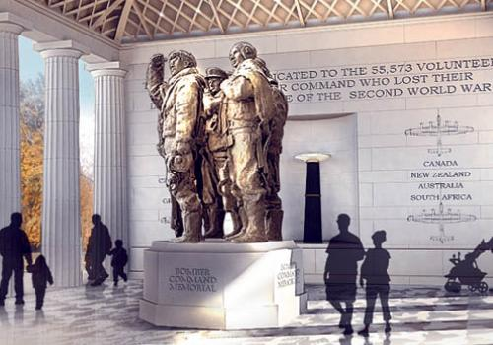
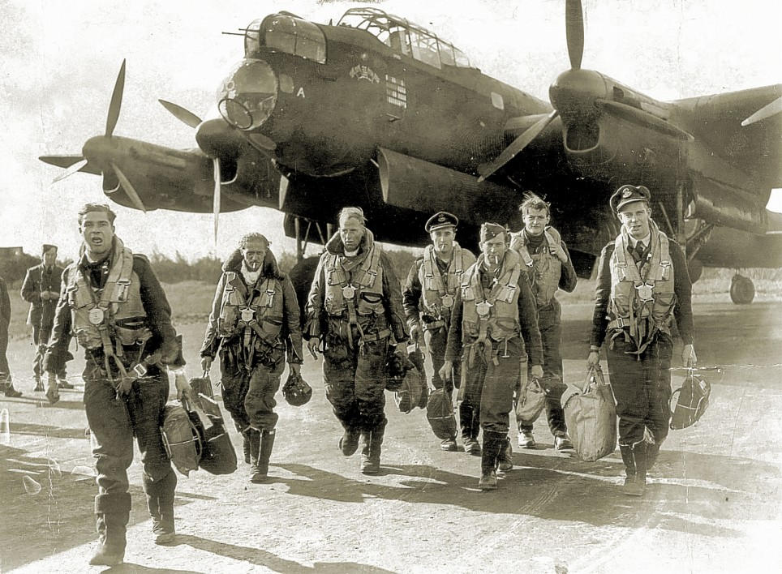
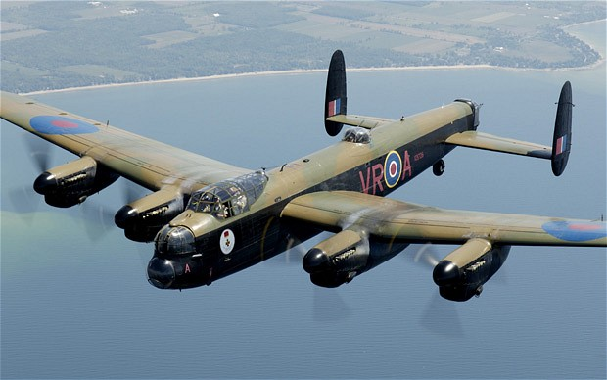
Sometimes I think we are better at remembering the dead than we are at doing the same for veterans. An example of this was on the Aus TV news the other night. This concerns the erection, in Green Park, near Buckingham Palace in London, of a memorial to the RAF Bomber Command and the 55000+ crew members who were killed. Bomber Command was a single unified command to control all bomber operations. I think 1942, 70 years ago, is important as that is when they began to strike heavy blows against Germany. (Flying bombers was extremely hazardous, particularly earlier in the war when fighters did not have to range to protect them all the way to Germany and back; the death rate was much higher than for the army, with the average age being only about 22.) All the surviving veterans are now in their 90s. The RNZAF and RAAF were part of Bomber Command. The NZ government is to fly all its veterans to London for the opening (I assume 'all' means those who want to go and are physically able to do so). Australia, by contrast, is to send just a handful - hence the controversy, which many regard as an insult. The cost of sending all of them would be much less than sending dignitaries and school choirs, etc to Gallipoli and France. The backbone of Bomber Command was the Lancaster bomber. After the war, I remember walking up the hill behind our house to see a Lancaster fly over the town; I can still recall it, though the plane is just a black shadow in my mind rather than having a distinct outline. When I went to HK to teach, the teacher standing in for me before I arrived was a Lancaster pilot who managed to survive, though he would not talk about it. He was a Canadian, many of whom went to the UK to fly bombers or fighters (which were part of Fighter Command). (The plaque in the second picture above lists Canada, NZ, Australia and SA, all of whom were part of Bomber Command.) One site:
http://oceankinguk2003.multiply.com/journal/item/2075
Bomber Command website:
http://www.rafbombercommand.com/master_welcome.html
Yesterday was a public holiday for Buddha's birthday. A tooth, which is supposed to be from the Buddha, was on display. This weekend was also bun festival on Cheung Chau. If there was rain, the bun tower scrambling competition would be cancelled (not postponed); I have not heard on the news if this happened.
That's about it.
Cheers

May ^{1st,} 2011
Hi
I am overwriting the letter from two years ago. I see that it was then that the first case of swine flu in HK was confirmed. It was a Mexican man who arrived on a flight from Mexico via Shanghai. At both Shanghai and HK airports, he was not picked up as having a temperature. Anyway, he checked in at a hotel in Wanchai, and, would you believe it, this hotel is owned by the same company than owns the hotel where the first person to have SARS was detected in 2003! The guy was quarantined in a hospital. In addition, the hotel, with all its 350 guests and staff, was quarantined for a week. Some, who did not want to stay in the hotel were moved to the Lady Maclehose holiday site in Sai Kung (a place some of you have stayed at, I think).
Last Monday was ANZAC Day. I said I was going to watch the dawn service at Gallipoli on Aus TV (10.30 am our time) but once I started work, I completely forgot to do so. Anyway, it would be very similar to that of other years.
The same day, I began swims for the new season and did three 1.5 km swims for the week. The first one was OK but seemed to take a long time. I am trying to change the style of my (overarm) stroke. Several months ago, Uncle Keith sent me an animation of a swimming style and I am trying to copy that. It may be working though it is not easy.
Tuesday was the 25th anniversary of Chernobyl nuclear accident.
On Friday morning, I went to the dentist. It was supposed to be for a possible cavity he had detected last time. Instead it was to replace an upper incisor filling that collapsed a couple of months ago (but was not causing me any trouble). Older fillings tend to do this. I thought it might have been a filling from my boyhood days but no, it was from just 20 years ago!
After exercise on Friday, and in the evening, I watched the royal wedding on TV. Both ATV and TVB broadcast it live. A very convenient time for us. I suppose it was broadcast in the US though it would have been early in the morning. It was interesting to watch. I liked the way Westminster Abbey had been decorated with rows of green trees on each side. Also, it looks different when lit up. Abbeys built in those days (about 1000 years ago), are very dark and dreary, mainly because the pillars had to be so big to support the structure that there was little room for windows. I can't remember if you have been into Westminster Abbey, but you have been into the one in Chatres, France built about the same time. (Remember? This is where Nadine managed to lose her hat. Also, next to the hostel we stayed at, there was a guy living in a caravan with some dogs, which you visited.) Back to the wedding. William does seem to have a respect for the military and a good touch was his salute as the coach passed the Cenotaph. As there was no guard on honour there that I could see, I assume it was for those soldiers commemorated by the Cenotaph. I am neither a confirmed monarchist nor a republican. I can see advantages in both systems.
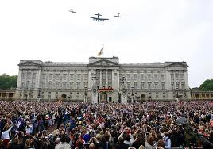
One thing I liked seeing was the fly-past by a 66-year old Lancaster bomber flanked by a Spitfire and a Hurricane. There were also shots from inside the cockpit of the Lancaster. This is one of only two serviceable Lancasters remaining. They use them for fly-pasts on other important occasions such as Battle of Britain Day and Remembrance Day (I think).
Did you hear about the Kate Middleton who lives in Boston? Saw her on TV here. She was a bit annoyed at being harassed by TV media who were asking her stupid things such as trying to get her to speak in a British accent.
HK's minimum wage law takes effect today.
In the letter two years ago, I mentioned the bus terminal rooftop garden below my window that had been completed but was not open. It is only a few weeks ago that people have started to use it, and even then very few. Most are from the adjacent housing estate. Few others as it is not visible from ground level.
That’s it for now.
Cheers

